Name: __________________________________ Period: ____________
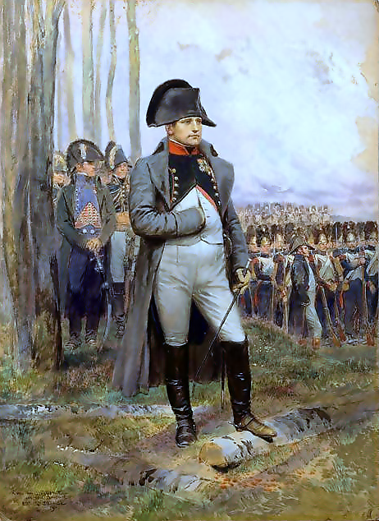
Napoleon Bonaparte – Rise and Fall in France
During the revolution in France, one general in particular began to outshine all the others. This general was a 26-year-old by the name of Napoleon Bonaparte.Napoleon’s skillful leadership helped to crush rebellions within France and also greatly expand the territories of France, including a surprising victory over the more powerful Austrian army.In October 1799, Napoleon returned to Paris after having been in Egypt with his armies to take part in a coup d’ etat, or an overthrow of the government.In 1804, Napoleon named himself as emperor of France and had himself anointed as such by the Pope.
Napoleon’s Rules France Napoleon was a masterful ruler. He established a number of reforms that brought peace and stability back to France. He also rewrote the old French feudal laws, which were confusing, creating a new Napoleonic Code of laws that were much clearer. In these codes, many injustices were eliminated – there was no longer a division between 1st, 2nd and 3rd Estates; however, the codes limited peoples freedoms and individual rights. In fact, freedom of speech and of the press – which were established during the French Revolution – where taken away by the Napoleonic Codes. Slavery was also restored in the French colonies in the Caribbean (ex: in Haiti). Napoleon also set up a better way of collecting taxes – no longer did the 1st and 2nd Estate get out of having to pay taxes. He also ended a lot of the corruption in the French government; people were only allowed to hold government positions (formerly only given to people of the 2nd Estate) in France if they qualified for the job, no longer were these jobs given based on family connections.
Napoleon’s Builds an Empire After bringing economic prosperity and peace to France, Napoleon set out to conquer the remainder of Europe. As a skillful general, he was able to conquer significant tracts of land. By 1812, Napoleon controlled most of Europe, either directly or indirectly.
Napoleon’s Empire Defeated Napoleon’s own personality proved to be the greatest danger to the future of his empire. His desire for power had raised him to great heights, and the same love of power led him to his doom. In his efforts to extend the French Empire, Napoleon made a number of disastrous mistakes. The nations that had been conquered by Napoleon resented being ruled by France. They did not like paying taxes to France; nor did they appreciate having to send their sons to fight as soldiers in the conquests that Napoleon was pursuing. People of these foreign countries were also beginning to feel abused by Napoleon. One by one, these nations rebelled, beginning with Spain. Napoleon’s biggest mistake came in 1812 when he invaded the country of Russia. Napoleon and his army of more than 420,00 soldiers marched into Russia. As Napoleon advanced, Alexander (the Czar of Russia) pulled his troops back into the country. On this retreat, the Russians practiced a scored-earth policy. This involved burning grain fields and slaughtering livestock so as to leave nothing for Napoleon’s troops to eat as they advanced.
Napoleon in Exile By March 1814, Napoleon had been defeated and was forced to step down as the emperor of France. A brother of King Louis XVI was placed on the throne of France.A year later in 1815, Napoleon returned to Paris and called for his soldiers to return to him. He was still popular among the people who had enjoyed their quick rise to power under his rule. For 100 days, Napoleon again ruled France. Monarchs in other European nations feared that Napoleon would again seek to control them. In June 1815, in a decisive battle at Waterloo, France, Napoleon was defeated and was forced into exile on the island of Saint Helena, where he died in 1821.

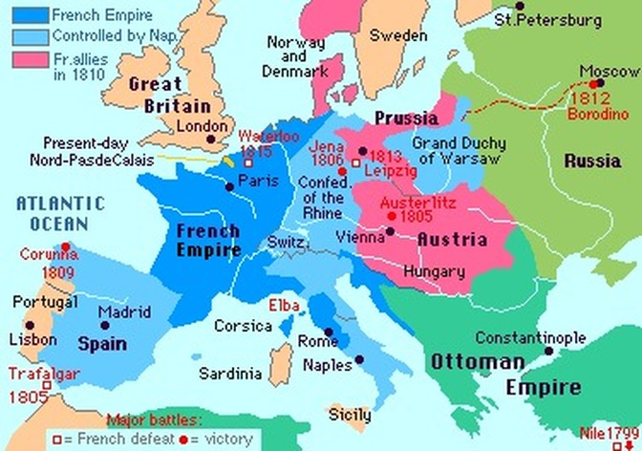
Document 1

Document 2
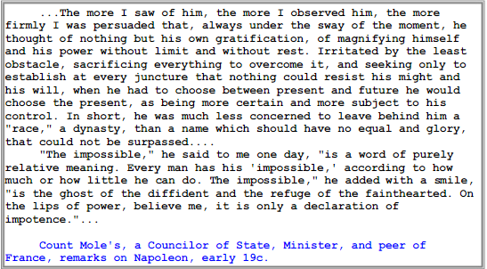
Document 3
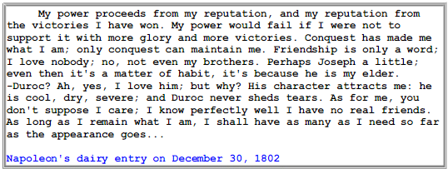
Document 4
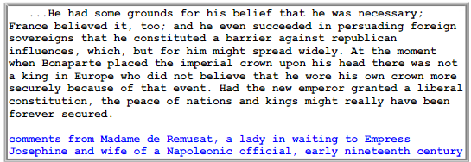

Document 5
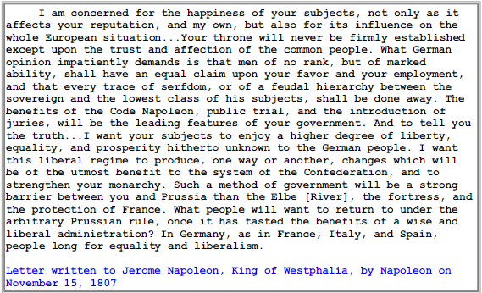

Document 6
“Of all our institutions public education is the most important. Everything depends on it, the present and the future. It is essential to the morals and the political ideas of the next generation. Above all it is essential to equality. I was not always a ruler. Before I became a ruler, I was a subject, and before that I was a student. I can never forget how powerfully the sentiment (feeling) of equality influenced my mind and excited my heart.”
Source: Napoleon Bonaparte, 1802, shortly after being appointed Consul (leader) of the French Republic

Document 7
